Results for p as a response variable, and 16 predictor variable(s).

n: 65535 r: 0.89 r²: 0.792 r²adj: 0.792 F: 15599.811 P: <.001

Akaike's Information Criterion (AICc): -149952.199

Variable Coeff. Std Coeff. VIF Std Error t P Value

Constant 1.208 0 0 0.013 96.388 <.001

bio_15 <.001 -0.038 6.574 <.001 -8.413 <.001

bio_19 -0.004 -0.342 5.394 <.001 -82.607 0

bio_3 <.001 -0.002 3.264 <.001 -0.61 0.542

bio_4 <.001 -0.871 4.868 <.001 -221.616 <.001

CST 0.003 0.034 1.11 <.001 18.247 <.001

HII 0.005 0.171 1.806 <.001 71.482 0

LUCC <.001 -0.027 1.198 <.001 -13.915 <.001

PC -16.53 -0.035 1.006 0.848 -19.5 <.001

s01 -0.75 -0.126 1.742 0.014 -53.587 <.001

s02 0.346 0.059 1.595 0.013 26.101 <.001

s03 0.361 0.061 1.898 0.014 25.017 <.001

s04 -1.573 -0.276 1.313 0.012 -135.264 0

s05 -0.967 -0.164 1.233 0.012 -82.666 <.001

s06 0.749 0.128 1.136 0.011 67.165 <.001

s07 -0.959 -0.165 1.115 0.011 -87.658 <.001

s08 0.992 0.17 1.295 0.012 83.743 0

Condition Number: 6.054

Mean of Correlation Matrix: 0.12

1st Eigenvalue divided by m: 0.189

Descriptive Statistics:

p Estimated Residuals

Min 0.002 -0.241 -0.285

Max 0.759 0.594 0.368

Mean 0.145 0.145 <.001

Std.Dev. 0.169 0.15 0.077

Skewness 0.603 0.324 0.347

Kurtosis-495556620.954 -495549936.549 -495558892.906

Partial Regression Results:

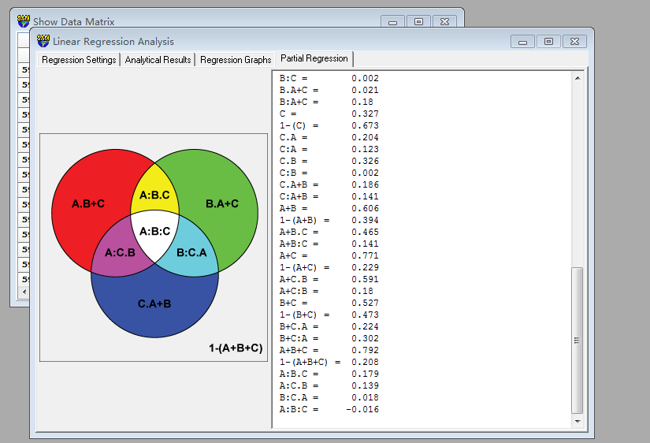 Predictor set {A}:

bio_15

bio_19

bio_3

bio_4

Predictor set {B}:

CST

HII

LUCC

PC

Predictor set {C}:

s01

s02

s03

s04

s05

s06

s07

s08

A = 0.568

1-(A) = 0.432

A.B = 0.405

A:B = 0.163

A.C = 0.444

A:C = 0.123

A.B+C = 0.265 a

A:B+C = 0.302

B = 0.201

1-(B) = 0.799

B.A = 0.038

B:A = 0.163

B.C = 0.199

B:C = 0.002

B.A+C = 0.021 b

B:A+C = 0.18

C = 0.327

1-(C) = 0.673

C.A = 0.204

C:A = 0.123

C.B = 0.326

C:B = 0.002

C.A+B = 0.186 c

C:A+B = 0.141

A+B = 0.606

1-(A+B) = 0.394

A+B.C = 0.465

A+B:C = 0.141

A+C = 0.771

1-(A+C) = 0.229

A+C.B = 0.591

A+C:B = 0.18

B+C = 0.527

1-(B+C) = 0.473

B+C.A = 0.224

B+C:A = 0.302

A+B+C = 0.792

1-(A+B+C) = 0.208

A:B.C = 0.179 d

A:C.B = 0.139 e

B:C.A = 0.018 f

A:B:C = -0.016 g